OS FINAL LAB EXAM REPORT
CS16BTECH11038 – Supreet Singh

Hungry Tribesman Problem

1. Input:
The program takes input from a file called “inp-params.txt”.
It takes 7 space-separated integers: K, M, n, a, b, l, m (as described in the assignment).

2. Design:
The program creates K tribesman threads, which try to eat from the pot. This design is similar to a sort of reader-writer problem and producer-consumer problem (some elements from both), where the number of readers is limited to M, each time M readers (tribesmen) eat (atomically) the pot must be refilled to M.

For this, I have used 4 semaphores:
a) rw_mutex: This is initialized to 0. A tribes-man thread waits on this semaphore when the pot is empty. The cook (main) thread routinely checks if the pot is empty, and if so, fills it and signals this semaphore (if some tribesman thread has called it, which is checked using variable gg). The tribesman waits on this semaphore to tell the cook to fill the pot.
b) fair: This is used by both cook and tribesmen to get solo access to pot_count variable, which stores the number of servings kept in the pot. Any thread which accesses pot_count, waits on this semaphore first.
c) nDLock: Used by cook thread to read a global variable which tells how many tribesmen have already finished eating n times. If all have, then the cook (main) thread exits.
d) mtx: Used by tribesmen, to make sure only 1 person eats / getsServing at a time.

Average waiting time is stored in a global variable wait_time.
I have used usleep to make the threads sleep, and have used POSIX threads and semaphores (as used in earlier assignments).

The cook thread is the main thread (since it was written only to create a total of K tribesman threads). It executes the loop as given in the assignment, only with synchronisation using semaphores. The functions putServingInPot() and cook-sleep() are implemented as in-line functions (function calls are avoided) inside the loop. If the pot is empty, then the cook (main) puts M servings into the pot atomically and signals rw_mtx if required. Otherwise, it just cooks and sleeps. Also at each iteration cook checks if all tribesman have done eating fully, using a global variable nDone.

The tribesmen threads call the function tribesman, which is passed a thread ID as a parameter. They simulate getServingFromPot() (atomically) and eat() and community-service(), once again through inlining and not actual function calls, inside the loop itself.

Each sleeping time is generated randomly, using random number generators, ea, and distributions ad, bd, ld, md. The means of the exponential distributions used are supplied by the input file.

A bool DEB is used if error messages are to be printed.

3. Output
The program outputs two files: log.txt and Average_time.txt

Log contains the log of all events, when some one became hungry, when he ate etc.

Average time.txt contains the average time taken by the threads to get their request fullfilled.

4. Analysis of Results
I have plotted a graph of K number of tribesmen (X-axis) threads vs average waiting time (seconds) – Y axis, with other parameters fixed.
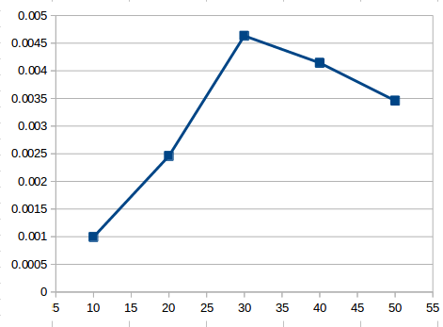

As the graph shows, the average waiting time first increase and then decreases on just increasing the number of tribesmen threads. Here M=20 and n=10.

After this, I varied M while keeping K fixed at 50 and n at 10. As can be seen, the average waiting time decreases on increasing M. Here M is on X-Axis.
